

Smart X Calculator

PROJECT REPORT

Submitted by:

Adithya k 711524BAM002
CSE(AI&ML)-IInd Year kit28.24bam009@gmail.com
Mahalakshmi A 711524BAM037
CSE(AI&ML)-IInd Year kit28.24bam058@gmail.com
Melvin Jessan 711524BAM041
CSE(AI&ML)-IInd Year kit28.24bam052@gmail.com
Harish R 711524BAM027
CSE(AI&ML)-IInd Year kishore881517@gmai1.com

Bachelor of Engineering (B.E) in
Rathivarshini R 711524BAM050
CSE(AI&ML)-IInd Year kit28.24bam061@gmai1.com
Tharun Dev U 711524BAM060
CSE(AI&ML)-IInd Year kit28.24bam061@gmai1.com

Computer Science ( Artificial Intelligence and Machine Learning)

KIT-KALAIGNARKARUNANIDHI INSTITUTE OF TECHNOLOGY
(An Autonomous Institution) COIMBATORE - 641402 ANNA UNIVERSITY CHENNAI 600 025
NOVEMBER 2025

INTERNAL EXAMINER EXTERNAL EXAMINER

BONAFIDE CERTIFICATE
This is to certify that the project report entitled “PULSECART” is the bonafide work of Adithya K (711524BAM002), Melvin Jessan(711524BAM041), Rathivarshini R (711524BAM050), Mahalakshmi S (711524BAM037), Harish R (711524BAM027) and
Tharun Dev U (711524BAM060)who carried out the project work under my supervision in partial fulfillment of the requirements for the degree of Bachelor of Engineering in Computer Science and Engineering during the academic year 2025-26.

SIGNATURE
Ms. Anu Priya A
Head of the Department Department of CSE(AI & ML)
KIT — Kalaignar Karunanidhi Institute of Technology Coimbatore — 641402
SIGNATURE
Ms. Priyanka A
Faculty Incharge
Department of CSE(AI&ML)
KIT — Kalaignar Karunanidhi Institute of Technology Coimbatore — 641402

Submitted for the Project Work Viva-Voce Examination held on 14/11/2025

INTERNAL EXAMINER EXTERNAL EXAMINER

Abstract
This project presents a Java-based Scientific Calculator application designed to perform both basic and advanced mathematical operations through an intuitive Graphical User Interface (GUI). The system is built using object-oriented programming principles, incorporating modular components such as a core calculator engine, a scientific operation handler, an interface for operation abstraction, and a dedicated log manager for storing calculation history. The GUI enables users to interact with the calculator efficiently, providing real-time results with clear input handling. This project demonstrates effective use of OOP concepts, event-driven programming, and Java Swing components to create a functional, user-friendly scientific calculator suitable for academic and practical use.
In addition, the project emphasizes code scalability and maintainability, allowing future enhancements such as additional scientific functions, improved UI design, or integration with external computational modules.

- Introduction
We express our sincere gratitude to our project mentor and faculty for their guidance, invaluable insights, and support throughout the development of this project. Their expertise helped in overcoming technical challenges and improving system architecture.

We thank our colleagues and peers for their collaborative spirit and timely feedback during iterative testing and refinement stages. Their encouragement inspired continued progress.

Appreciation is also extended to the open-source communities and documentation available which aided in understanding frameworks and Java libraries, especially for GUI and file management. Finally, we acknowledge the patience and support of our
families for facilitating a conducive environment for focused work.

Introduction
The Scientific Calculator project is designed to provide a reliable and efficient platform for performing a wide range of mathematical operations using Java. The system expands beyond basic arithmetic by integrating advanced scientific functions, making it suitable for both academic and practical applications. The project follows a modular, object-oriented architecture consisting of a standard calculator engine, an extended scientific operations module, an abstraction interface for method consistency, and a log manager responsible for storing calculation history.
A graphical user interface (GUI) built with Java Swing serves as the rimary interaction layer, enabling users to lh ut expressions, perform calculations, and view results in real time. The interface handles user actions through event-driven programming, ensuring smooth and error-free execution. By combining OOP concepts, clear modular separation, and an interactive GUI, this project demonstrates how Java can be used to build maintainable, scalable, and user-friendly applications.

Proposed Methodology
- The project adopts a modular Object-Oriented Programming (OOP) structure ensuring clean separation of responsibilities.

Core calculation logic is split into distinct classes: Calculator, ScientificCalculator, Operable, and LogManager.

- Java Swing is used to design an interactive GUI with buttons, display panels, and event listeners.

- The Operable interface enforces consistent operation methods across different calculator modules.

- Inheritance extends the basic calculator to support advanced scientific functions.

- Real-time calculation results are handled using event-driven programming, linking each GUI element to specific backend logic.

- A dedicated LogManager manages the storage and retrieval of calculation history for transparency and debugging.

- Exception handling ensures safe execution, preventing crashes during invalid inputs, division errors, or malformed expressions.

- Encapsulation secures internal variables and prevents unintended access from the GUI layer.

- Iterative testing validates correctness of arithmetic and scientific functions, GUI responsiveness, and error handling.

Project Explanation

  - OOPS Concepts Applied
    - Encapsulation: Core variables such as operands, current input, operator
state, and display values are kept private inside the calculator and GUI classes, accessed only through controlled methods.

Abstraction: The Operable interface defines common operation contracts, allowing both basic and scientific calculators to implement their own logic without exposing internal details.

Inheritance: ScientificCaIculator extends the base Calculator class to reuse arithmetic logic and add advanced scientific functions (trigonometry, logarithms, power, etc.).

Polymorphism: Both Calculator and ScientificCalculator override the same interface methods, allowing dynamic method execution depending on the calculator mode.

Modularity: Core components (Calculator engine, Scientific calculations, GUI handler, logging system) are separated into independent classes.

Reusability: Calculation methods and utility functions are reused across GUI actions and different button events.

Clarity: Each class has a clear responsibility—GUI manages visuals, Calculator handles logic, LogManager manages history.

Extensibility: New mathematical functions can be added to ScientificCalculator without altering the existing base logic or GUI structure.

Exception Handling
    - Invalid input handling prevents the calculator from crashing on malformed expressions or empty operations.

    - Arithmetic exceptions (e.g., division by zero, invalid operations) are caught and handled with safe messages.

    - Try-catch blocks wrap critical execution areas such as parsing, scientific function evaluation, and GUI updates.

    - Number format validation ensures the system does not execute operations on non-numeric or incomplete inputs.

    - GUI-level error messages provide immediate feedback to users to correct invalid actions.

    - LogManager error handling ensures logging continues even when file operations fail.

    - Method-level exception control keeps system behavior predictable and stable.

    - Overall reliability is improved by preventing unexpected termination during user interaction.

FileInput/Output
    - Text-based logging stores the history of operations using the LogManager class.

    - BufferedWriter and FileWriter are used for efficient writing of calculation logs.

    - Log structure maintains readable entries for operation tracking and debugging.

    - Sequential writes record each completed expression and its result.

    - File retrieval methods allow viewing past calculations when required.

    - Logs act as persistent storage to track user activity across sessions.

    - Safe I/O execution ensured by wrapping file operations in try-catch blocks.

    - Scalable design allows future migration to JSON, database, or cloud-based logs.

Serialization

    - If serialization is added later for saving calculator state:
    - Serializable interface can be applied to store calculator state or session data.

    - Object stream handling enables saving and restoring recent operations.

Useful for session backup, storing last operation, or advanced features.

Complements log files for more structured state storage.

Prevents rigid data structures,
enabling flexible extension.

    - Smooth future migration to more advanced data structures or databases.

Supports future expansion like syncing states or sharing data across systems.

Component Purpose & Features Class
Name

Key Interacti
Methods ons

Enables deeper Java functionality
beyond basic file logging.
Core Handles basic Ga lcu lat add, GUI,
Calculator arithmetic operations o r subtract, Scientifi
multiply, cCalculat
divide or

Scientific Trigonometry, logs, Sc ien t if sin, cos, Calculat
*unc'°°' p°w"s,'°°G› icCalcul *'°g, or,GtJ

Can integrate with GUI memory
advanced math
a t r
pow, SQFt

features (e.g., saving custom variables).
Operation Defines common Abstraction methods for all
calculators
Ope rab Ie p >' Calculat
clear
Scientifi cCalculat

Enhances scalability for more complex future versions.

Calculation Stores history of LogHanag writeLog, GUI,
Logging operations and results • r readLog Calculat

Graphical Button layout, Ca lc ulat actionPerf Calculat
User display, user input 0 l"cui ormed, or &
Interface handling updateDis Scientifi
play cCalculat

  - Usage of Collections
Event Connects button actions to backend
Inside GUI handlelnp GUI —r
ut, Calculat
handleOpe or rator

ArrayList can store calculation history entries internally before writing logs.

Lists support dynamic updates,
useful for undo/redo features or

Input Validates and formats GUI & Processing user-entered numbers Calculator

- Results and Outputs

parseInput Calculat
Scientifi cCalculat

history display.

Collections enhance searchability
within past operations.

Efficient management of multiple expressions and results.

Useful abstraction layer between LogManager and GUI.

Simplifies data processing for displaying recent calculations.
The Scientific Calculator system provides a complete mathematical computation workflow with:
- Responsive graphical interface developed using Java Swing, featuring number keys, operators, and scientific function panels.

- Accurate execution of both basic and advanced operations, including addition, subtraction, multiplication, division, trigonometric functions, logarithms, exponentiation, and square

roots.

  - Dynamic display update that reflects each user input, operator press, and generated result in real time.

  - Robust input handling that prevents invalid expressions, incomplete entries, or incorrect numeric formats from causing crashes.

  - Clear error messages shown directly on the GUI when operations like division by zero or invalid calculations occur.

  - Integrated calculation history, maintained through a logging mechanism that stores expressions and results for future reference.

  - Event-driven behavior where each button triggers its corresponding backend logic for precise, immediate output.

  - Consistent performance, ensuring smooth transitions between basic and scientific modes without lag or computation delays.
Output Before GUI

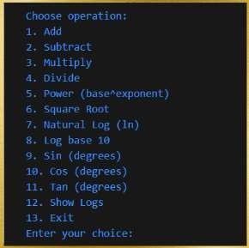
Output With GUI
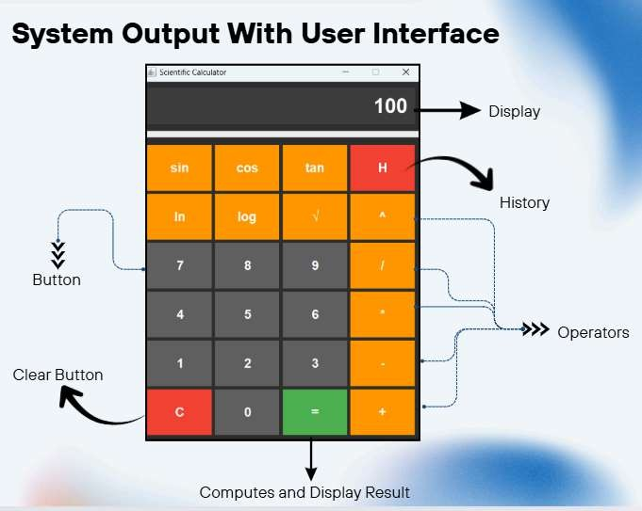

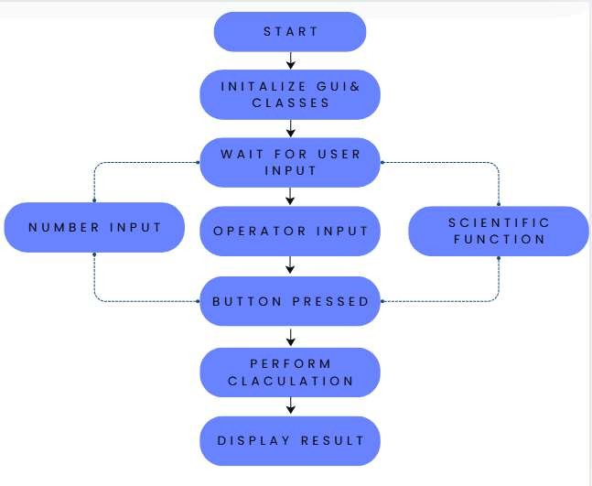
Conclusion
  - The Scientific Calculator project successfully demonstrates how Java, combined with object-oriented programming and Swing-based GUI design, can be used to build a functional and user-friendly computational tool. The system handles both basic arithmetic and advanced scientific operations with accuracy, providing real-time results

through an intuitive graphical interface. By applying core OOP principles such as inheritance, abstraction, encapsulation, and polymorphism, the project achieves a clean modular structure that is easy to maintain and extend.
- Robust exception handling ensures smooth operation even during invalid inputs or complex calculations, while the integrated logging mechanism supports tracking and reviewing past computations. The overall design emphasizes clarity, reliability, and usability, delivering a stable application suitable for academic learning and everyday mathematical tasks. This project demonstrates practical application of Java concepts and provides a solid foundation for future enhancements and more advanced computational features.

